Supplementary table 1 Primers sequences used in this study
Targets | sequences
 | Forward:5’-3’ | Reverse:5’-3’
LncRNA-NEAT1 | CTTCCTCCCTTTAACTTATCCATTCAC | CTCTTCCTCCACCATTACCAACAATAC
UCK2 | CTAGCGGCAAGTCTTCCGTG | TGCTGCACGATGAGGTTGAT
GAPDH | GTCTCCTCTGACTTCAACAGCG | ACCACCCTGTTGCTGTAGCCAA
U6 | CTCGCTTCGGCAGCACA | AACGCTTCACGAATTTGCGT
microRNA-199a-3p | acagTagTcTgcacaTTggTTa | mRQ 3’ Primer in kit
microRNA-483a-3p | TcacTccTcTccTcccgTcTT | mRQ 3’ Primer in kit
microRNA-486a-3p | cggggcagcTcagTacaggaT | mRQ 3’ Primer in kit
microRNA-582-5p | TTacagTTgTTcaaccagTTacT | mRQ 3’ Primer in kit
microRNA-129a-5p | cTTTTTgcggTcTgggcTTgc | mRQ 3’ Primer in kit
Primers in ChIp assay | AACCACCGCCCGAAAGTC | CCGGCAGGACATCTGGAAAA

Supplementary table 2 Significantly down-regulated microRNAs in pcDNA3.1-NEAT1 transfected SNU-182 cells
hsa-miR-942-3p | hsa-miR-302c-3p | hsa-miR-10b-3p | hsa-miR-671-5p
hsa-miR-3138 | hsa-miR-4480 | hsa-miR-129-5p | hsa-miR-519e-5p
hsa-miR-515-3p | hsa-miR-199a-3p | hsa-miR-95-3p | hsa-miR-582-5p
hsa-miR-640 | hsa-miR-143-3p | hsa-miR-532-3p
hsa-miR-214-5p | hsa-miR-483-3p | hsa-miR-486-5p
hsa-miR-4266 | hsa-miR-301a-5p | hsa-miR-204-3p
hsa-miR-514b-3p | hsa-miR-34a-5p | hsa-miR-7978
hsa-miR-6507-5p | hsa-miR-7161-5p | hsa-miR-1301-5p
hsa-miR-329-5p | hsa-miR-6077 | hsa-miR-128-3p
hsa-miR-4429 | hsa-miR-6890-3p | hsa-miR-659-5p
hsa-miR-519d-5p | hsa-miR-194-3p | hsa-miR-6784-5p
hsa-miR-106a-5p | hsa-miR-139-5p | hsa-miR-187-3p
hsa-miR-6515-5p | hsa-miR-1914-3p | hsa-miR-378d
hsa-miR-6072 | hsa-miR-578 | hsa-miR-5681a
hsa-miR-4704-5p | hsa-miR-1251-3p | hsa-miR-1254
hsa-miR-383-3p | hsa-miR-1251-5p | hsa-miR-4796-3p
hsa-miR-197-5p | hsa-miR-934 | hsa-miR-33a-5p
hsa-miR-3198 | hsa-miR-4732-5p | hsa-miR-542-3p
hsa-miR-3121-5p | hsa-miR-4764-5p | hsa-miR-6794-3p
hsa-miR-142-5p | hsa-miR-513b-5p | hsa-miR-6778-5p
microRNAs with Log 2 (Fold change) < -0.58 and P<0.05 were defined as significantly down-regulated microRNAs
Supplementary table 3 Significantly up-regulated mRNAs in pcDNA3.1-NEAT1 transfected SNU-182 cells
TLDC1 | CBX7 | PIGK | IL17RB | CAPN13 | NFIC | JUNB | EFEMP2
VPS53 | ENTHD1 | IFI44L | LPGAT1 | PRKD3 | PIAS4 | TP53I11 | RGS5
SLC43A2 | TNRC6B | PRKACB | GINS4 | PREPL | ELAVL1 | CYB561A3 | EMP2
SMYD4 | UCK2 | SH3GLB1 | HOOK3 | NRXN1 | ZNF426 | SEMA7A | RPL35P5
GALNT6 | TOB2 | C1RL | VCPIP1 | PNPT1 | C19orf66 | SLC14A1 | LIF
MMP19 | LRRC1 | DENND5B | SGK3 | PAPOLG | ELAVL3 | MUC1 | RBX1
RBMS2 | CDKL5 | FGD4 | ELOC | UBR5 | FKBP5 | TUBA1C | RPS20P14
INHBC | SH3KBP1 | PPHLN1 | ZC2HC1A | ZNF655 | KCTD20 | RPS5 | RDH5
SLC16A7 | USP9X | TRIP13 | PAG1 | ZKSCAN1 | BTBD9 | TUBB4B | DUSP12
TBC1D30 | TMEM74 | ADCY2 | UQCRB | IFT22 | RPL7L1 | EEF1B2P3 | CLIC1
CPM | EFR3A | ANKH | DCAF4L1 | CUX1 | PAQR8 | HIST1H3B | VPS45
FAM155A | AK3 | CDH12 | GABRA4 | COG5 | RAB23 | ANO3 | ATP6V1C1
AP4S1 | LINGO2 | C1QTNF3 | FRYL | TMEM168 | EYS | GREM2 | MCM7
DTD2 | S100A2 | CCDC125 | SGCB | KCND2 | PGM3 | RARRES3 | TTK
KLHL28 | ATP8B2 | F2R | CHIC2 | SLC13A1 | AURKA | HIST1H3I | KIAA0907
L2HGDH | LMNA | ZFYVE16 | CLOCK | CEP41 | PRC1 | PLK1 | STIP1
H2AFV | MEF2D | RASGRF2 | RUFY3 | DGKI | HTR2B | IFITM2 | PARP1
TYW1 | CD1B | POGK | RASSF6 | CREB3L2 | FAM43A | RPLP2 | GOLPH3L
TYW1B | GINS2 | GPR161 | LIN54 | ZNF563 | KRT18 | PLK2 | HLTF
HIP1 | NOS1AP | CACYBP | WDFY3 | MRI1 | HSPB7 | TOP2A | RGS5
STEAP2 | ZNF264 | GLUL | SESTD1 | IL27RA | IFITM3 | DTL | CHD1L
GTPBP10 | PKNOX1 | NMNAT2 | DAPP1 | NWD1 | KIF20A | RELN | MEP1A
GATAD1 | ICOSLG | CDK4 | RRAGD | UNC13A | PRC1 | IFI6 | CANT1
RBM48 | ADARB1 | IPO9 | PRDM1 | ZNF101 | SNRPB | B3GAT3 | POLR3C
DLK1 | TMEM121B | MDM4 | SOBP | ZNF626 | TAGLN | CLDN11 | TRIP13
PTCD1 | SNAP29 | RASSF5 | TRAF3IP2 | ZFP82 | PSG7 | EMILIN1 | KLHL12
PPP2R3A | LRRC74B | IPCEF1 | NT5DC1 | CELF1 | PTGS1 | NENF | LSM2
SOX14 | HIC2 | GTF2H5 | KIAA0408 | SLC43A1 | SECTM1 | DLGAP5 | CD34
GK5 | TTF2 | TULP4 | SLC2A12 | ZFP91 | ACTA2 | ATP6V0B | LCN2
U2SURP | LCN10 | IQCE | HBS1L | TMEM223 | KRT18 | KRT18P11 | SLC39A1
RNF13 | KLF6 | SP4 | PERP | COL25A1 | SDC4 | IGFBP6 | CLDN15
GPR171 | BEND7 | CREB5 | PHACTR2 | BBS12 | TPM2 | TNFRSF12A | MICB
MME | DCLRE1C | WIPF3 | EPM2A | ABHD18 | HLA-B | BUB1B | POGK
IFT80 | TRDMT1 | PLEKHA8 | CCDC170 | JADE1 | IFITM1 | RPS10 | FANCI
NMD3 | TMEM236 | DDHD1 | ESR1 | NAA15 | TPI1P1 | HLA-C | TRIM24
TTC14 | NEBL | PELI2 | LIN28A | GYPA | TIPARP | LMOD1 | UBE2Q1
KLHL24 | MPP7 | DHRS7 | PHACTR4 | FNIP2 | PTTG1 | LGALS1 | NEDD4L
NXT2 | EPC1 | DCAF5 | ZBTB8A | TMEM192 | DDT | SPOCD1 | SRXN1
ACSL4 | CREM | RBM25 | FNDC5 | MFAP3L | SLIRP | SEC61B | HMGB2
AMMECR1 | ZNF33A | VIPAS39 | MEAF6 | JAKMIP2 | SNHG17 | GSTP1 | CCNA2
PAK3 | RET | FOXN3 | AKIRIN1 | FAM114A2 | CHCHD2 | MFSD5 | CLN3
ZBTB33 | VSTM4 | EFCAB11 | OSBPL8 | TMEM97 | HIST1H2BM | MYADM | TUBG1
MCTS1 | ERCC6 | CALM1 | SOCS2 | PHF12 | COX8A | TGFB1I1 | TAGLN2
XIAP | KLF17 | TC2N | VEZT | GOSR1 | CNN1 | PBK | CCT3
AFF2 | TOE1 | MYRIP | ARL1 | MMP28 | PFN1P2 | TPI1 | GMPS
GABRA3 | RAB3B | ZNF621 | CMKLR1 | SMIM21 | HAPLN3 | TK1 | TK1
PCDH11Y | NFIA | LRRC2 | VSIG10 | ZNF516 | SNED1 | WDR83OS | FDPS
ANKRD54 | KANK4 | PRKAR2A | LDAH | PARD6G | PLIN3 | SEC61G | CCNB1
SUN2 | LEPROT | HEMK1 | UBL4A | POLR2E | ACAN | TUBB3 | BUB1B
CENPF | NPLOC4 | SETDB1 | AATF | MTX1 | DAP3 | TYMS | SCGN
BARD1 | CKAP2L | SMC4 | KIF4A | HSPB1 | NUAK1

mRNA with Log 2 (Fold change) >0.58 and P<0.05 were defined as significantly up-regulated mRNAs

Supplementary figures
Supplementary figure 1
Transfection efficiency of vectors, siRNA, microRNA mimics and microRNA inhibitors were confirmed in SNU-182 cells. a the effect of pcDNA3.1 overexpression vector on NEAT1 and UCK2 level. b the effect of siRNAs on NEAT1, HIF-1α and UCK2 level. c the effect of microRNA mimics and inhibitors on candidate microRNAs. d the effect of lentivirus system on NEAT1, microRNA-199a-3p and UCK2 level. *P<0.05 compared with transfection negative control.

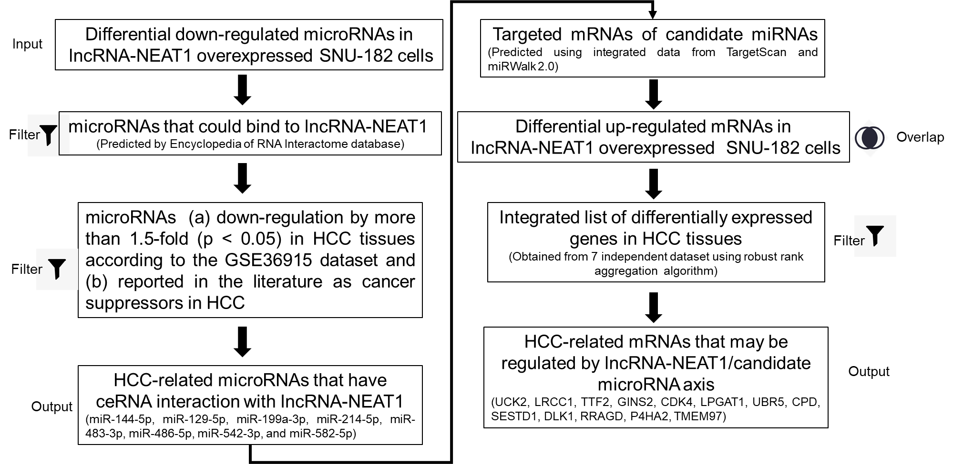
Supplementary figure 2
The workflow to build the HCC-related lnc-NEAT1/microRNA/mRNA ceRNA network.

Supplementary figure 3
LncRNA-NEAT1 sustained the growth of HUH7 cells under hypoxic conditions. a The expression of lncRNA-NEAT1 was altered by transfection with the pcDNA3.1-NEAT1 vector or siRNA-NEAT1. After transfection for 24 h, cells were cultured under hypoxic or normoxic conditions. Cell viability was detected using CCK-8 assay and used to estimate proliferation. b and c The roles of lncRNA-NEAT1 on apoptosis and the cell cycle of HUH7 cells under hypoxic and normoxic conditions were assessed by flow cytometry. *P<0.05 compared with transfection negative control. #P<0.05 compared with pcDNA3.1-NEAT1.
Supplementary figure 4
LncRNA-NEAT1 sustains the growth of HUH7 cells under hypoxic conditions by regulating miR-199a-3p/UCK2. a the expression levels of miR-199a-3p and UCK2 in HUH7 were up-regulated by transfection. On the other hand, miR-199a-3p or siRNA-UCK2 were co-transfected with pcDNA3.1-NEAT1 in HUH7 cells under hypoxia. The cell proliferation changes were determined with the CCK-8 assay. b and c the effects of miR-199a-3p and UCK2 on apoptosis and the cycle of HUH7 cells were determined by flow cytometry. *P<0.05 compared with transfection negative control. #P<0.05 compared with pcDNA3.1-NEAT1.

